When the Investor Moves, the Tax Story Changes

Part 2 of 3 Kenya, Britain, Ireland, and the meaning of tax residence
Amina, Brian, and Catherine have reached an agreement about the investment itself. They understand that an Irish fund can hold American shares and trade in several currencies, and that accumulation describes what happens to income inside the fund. Then Catherine asks a question that changes the discussion: if they own the same share class, why would they file different tax returns? The answer lies in the investor’s circumstances. A portfolio can remain untouched while a move, a new residence status, or the passage of a tax year changes its treatment. These fictional siblings help us examine that transition without assuming that every Kenyan abroad has the same obligations. This article uses official rules checked on 7 September 2026, with hypothetical calculations to show their operation. Kenya, Britain, Ireland, and Germany serve as specific examples; they do not represent a single diaspora tax system.
Tax residence, citizenship, immigration permission, fund domicile, and account address describe different things. A Kenyan citizen can become resident for tax purposes elsewhere, while retaining financial and family ties to Kenya. A broker’s address field is evidence supplied to an institution, rather than a mechanism for choosing the most convenient tax jurisdiction. Similarly, the Irish domicile of a fund does not make its shareholder an Irish resident. The useful first step is to write down the person’s actual facts: where they live, where they work, which homes are available, how much time they spend in each country, and whether another citizenship or tax status introduces additional rules. The resulting file may look less exciting than a portfolio chart, but it supplies the foundation for every subsequent calculation. Starting with a desired tax rate and working backwards toward an address reverses that necessary order.

Kenya begin with residence and source
Kenya’s residence tests extend beyond the familiar 183-day figure. KRA’s glossary describes residence where an individual has a permanent home in Kenya and is present for any period during the year. Without such a permanent home, the alternatives include at least 183 days in the year, or presence in that year and the two preceding years averaging more than 122 days annually [1]. This matters to someone who divides working time between Nairobi and another country. A current-year stay shorter than 183 days does not settle the question by itself. The permanent-home branch must be considered first, and the three-year branch requires the earlier travel record. These are domestic residence tests; whether a treaty subsequently allocates residence differently is a further question. Keeping the stages separate prevents a rough travel estimate from becoming an unsupported conclusion about the whole tax position.
Consider an individual with no permanent home in Kenya who spends 130 days there in 2024, 120 days in 2025, and 120 days in 2026. The three-year average is approximately 123.33 days, above the 122-day threshold, and the person is present in each year. Under that branch of the domestic test, the 120-day stay in 2026 can therefore contribute to Kenyan residence. The example is intentionally simple: it assumes the days have been counted correctly and does not attempt to resolve another country’s competing claim. Its value is to expose the weakness of using a single number from memory. Amina can maintain a calendar with travel dates and supporting records, then apply the actual branches of the rule. If an average were exactly 122 days, the wording “more than” would matter; rounding an estimate too early could change the apparent conclusion.

Worked calculation 1 The three-year residence branch
Assumptions: no permanent home in Kenya; presence in all three years.
Average annual days = (2024 days + 2025 days + 2026 days) ÷ 3
= (130 + 120 + 120) ÷ 3
= 370 ÷ 3 = 123.3333 days
123.3333 > 122, so this domestic residence branch is satisfied.
This is not a treaty residence determination.
Residence then needs to be connected to the character and source of the income. KRA describes Kenya’s system as source-based, while identifying exceptions that include foreign employment income of resident individuals and business carried on partly within and partly outside Kenya [2]. It follows that an overseas payment is not automatically outside Kenyan taxation. Equally, one should not assume that every genuinely foreign portfolio receipt is taxable merely because its owner is Kenyan. The correct analysis identifies what generated the amount, where the relevant activity or asset sits, and whether a deeming provision applies. For an ordinary overseas ETF holding, the file should distinguish distributions, realised disposal gains, returned capital, and interest on idle cash. The source notes’ broad language about foreign investment income needs this more precise treatment. Account location and payment destination are insufficient substitutes for classifying the actual item under the applicable rules.
Remitting money is a separate event from earning it, even though the two sometimes happen close together. Imagine Brian transfers £5,000 from one account he owns to another. The transfer could contain previously taxed salary savings, a recent investment distribution, sale proceeds containing both original capital and a gain, or several of these components. The payment receipt alone cannot reveal the composition. A practical record therefore links the transferred amount to the transactions that produced it. This also helps avoid treating the entire proceeds of an investment sale as profit. If an asset purchased for £8,000 is sold for £10,000, the starting economic gain is £2,000 before relevant adjustments, rather than £10,000. Whether that gain is taxable, and in which country, requires the legal analysis. Sending the proceeds home does not supply the missing classification, nor does leaving them offshore settle it.
KRA’s capital-gains guidance provides another reason to inspect the underlying connection rather than the label “foreign.” It covers Kenyan property and certain indirect interests, including specified foreign entities deriving value from Kenyan immovable property; its published rate for taxable net gains is 15% [3]. That does not justify applying 15% automatically to every sale of an overseas ETF. It does demonstrate that incorporation outside Kenya does not always remove a Kenyan tax connection. For this series, the responsible conclusion is bounded: an ordinary foreign portfolio investment needs a source and character assessment, while investments with Kenyan property or company exposure may raise additional provisions. A reader taking a material position can make professional review efficient by supplying the fund identifier, transaction history, residence facts, and the precise question. The objective is a documented answer about an identifiable asset, rather than a general reassurance about offshore money.

Two countries can ask the residence question
Dual residence under domestic laws is possible, which is where a relevant treaty becomes especially useful. The UK–Kenya agreement provides a sequence for individuals involving permanent home, centre of vital interests, habitual abode, nationality, and ultimately agreement between the authorities [4]. Those concepts call for facts, particularly when a person keeps a family home in one country while working in another. A treaty analysis comes after examining the domestic rules; it is not replaced by selecting a single country inside an app. Nor does the existence of a treaty mean every income item receives the same relief. The relevant article, income category, and claim requirements still matter. For Brian, gathering evidence about his work and household arrangements is therefore part of financial planning. His circumstances can be intelligible and well documented even when the legal conclusion requires more than counting the stamps in his passport.
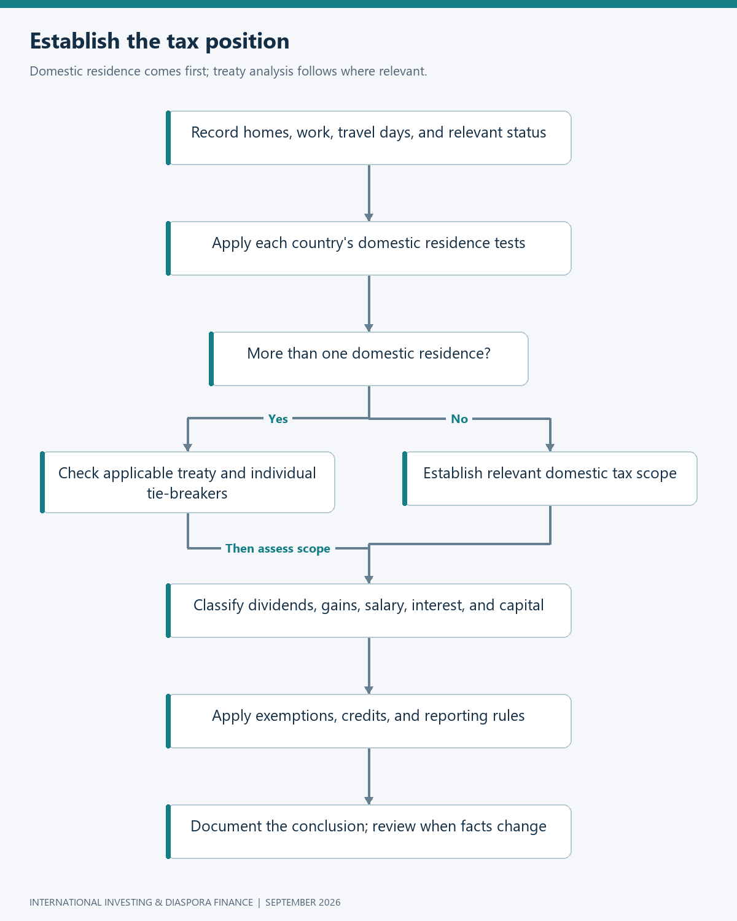
Flowchart: residence analysis
Britain introduces a different calendar as well as a different set of tests. Its tax year runs from 6 April to 5 April, and the statutory residence framework includes automatic overseas tests, automatic UK tests, and sufficient ties [5]. Spending 183 days in the UK can establish residence, but spending fewer does not automatically establish nonresidence. For someone arriving from or returning to Kenya, this makes a single calendar-year travel summary inadequate. The same trip must be allocated to the correct tax period in each jurisdiction. Split-year treatment and temporary-nonresidence rules can also matter, so a planned disposal shortly before or after moving deserves review before the transaction. The practical response is to build a timeline around actual dates and proposed actions. Once the chronology is clear, an adviser can evaluate the rules much more effectively than when presented with the statement that someone “moved abroad last year.”

Britain cash received is only part of the picture
UK residents normally pay UK tax on foreign income, subject to available reliefs [6]. That starting point matters because the original notes sometimes associated keeping money overseas with avoiding a tax event. A payment’s location does not generally provide that result. Since 6 April 2025, the four-year foreign income and gains regime has replaced the former remittance-basis framework for qualifying new residents [7]. Broadly, eligibility depends on becoming UK resident after at least ten consecutive tax years of non-UK residence, with relief available through claims during the first four UK-resident tax years. This is a specific regime with conditions, rather than a benefit automatically attached to being a Kenyan newcomer. Brian needs to establish whether he qualifies, which income or gains are covered, and whether claiming is worthwhile in the particular year. An old discussion of domicile and unremitted income may no longer describe the current starting point.
The decision to claim relief should include its consequences for other allowances. HMRC explains that a foreign income and gains claim involves giving up specified allowances, including the personal allowance and the capital-gains annual exempt amount [7]. A small foreign-income saving can therefore be outweighed by additional tax elsewhere. The illustration below uses hypothetical tax effects rather than current tax bands: suppose relief saves £1,200 on foreign income but lost allowances increase other tax by £1,600. The net effect is £400 more tax, before any administrative cost. This does not suggest that eligible people should generally avoid the regime. It shows why the relevant calculation concerns the whole return. Brian can ask for a comparison with and without the claim, using his actual income categories and allowances. A relief can be valuable while still requiring arithmetic; eligibility and financial benefit are related questions that deserve separate answers.

Worked calculation 2 Evaluate relief across the whole return
Net tax benefit = foreign tax otherwise payable and relieved
− additional tax caused by allowances lost
Illustrative benefit = £1,200 − £1,600 = −£400
A negative result means £400 more total tax in this hypothetical comparison.
The figures are assumed tax effects, not quoted tax rates or allowance amounts.
Offshore reporting funds create another distinction between money received and income recognised. HMRC’s HS265 guidance explains that investors can be taxed on reportable income exceeding the amount actually distributed, usually called excess reported income, or ERI [8]. An accumulating fund can therefore generate taxable income without paying cash to the investor. Reporting status must be checked for the relevant share class, and the timing of deemed receipt matters: ERI is generally treated as received six months after the reporting period ends. The significance for Brian is operational. His broker statement showing no dividend payment does not establish that there is no amount to report. He needs the fund’s investor tax report and the relevant year-end unit holding, subject to applicable adjustments. This is a good example of a tax obligation that becomes manageable once the necessary document is identified and collected routinely.
Assume Brian owns 1,000 units at the relevant reporting-period end and the fund publishes ERI of £0.80 per unit. The illustrative amount is £800. If the units originally cost £10,000 and are later sold for £12,000, previously arising relevant ERI must be accounted for in determining the disposal gain so that the same income is not counted again [8]. Under the simplified assumptions below, the adjusted gain becomes £1,200. This calculation assumes an ordinary taxable reporting-fund holding, no applicable special relief, no equalisation complications, and no other cost adjustments. It illustrates two different records: income recognised during ownership and the basis used when calculating a later gain. Keeping both records is more important than whether the fund’s interface uses a reassuring “Acc” label. The tax analysis follows the published information and relevant rules, while the cash balance remains only one part of the evidence.

Worked calculation 3 ERI and the later disposal gain
ERI = relevant period-end units × published ERI per unit
= 1,000 × £0.80 = £800
Simplified later gain = proceeds − original cost − relevant prior ERI
= £12,000 − £10,000 − £800
= £1,200
The £800 income and £1,200 disposal gain can arise in different tax years.
No tax rate is assumed; this calculates the amounts requiring classification.
The family can turn this example into a small annual workflow. Save the fund’s tax report, record the reporting period, reconcile the units held at its end, and preserve the calculation alongside the broker statement. On disposal, retrieve the accumulated history instead of beginning again with the original purchase confirmation. This workflow also highlights a product-selection cost that rarely appears in an expense ratio: the time required to obtain reliable tax information. A fund with clear, accessible reporting may be easier to hold than a superficially cheaper product whose relevant documents are difficult to locate. For Brian, a simple investment strategy includes the administration needed to keep it simple. He does not need to become a fund accountant, but he should be able to identify what information is missing and who is responsible for supplying it before the tax-return deadline approaches.

A tax wrapper travels under its own rules
An ISA can materially change the UK treatment of investments held within it, but moving abroad introduces conditions. HMRC states that a person becoming non-UK resident normally cannot continue subscribing, subject to specific exceptions, while an existing ISA can remain open and retain its UK tax relief [9]. The word “UK” is essential: that guidance does not establish how Kenya, Ireland, or another new residence country treats the account. Brian should notify the provider and distinguish retaining an existing holding from making new contributions. He should also examine what his new country considers the underlying income and gains. The account’s familiar name does not bind another tax authority. This is why a relocation review should inventory wrappers separately from ordinary brokerage accounts. Two accounts holding the same fund can have different treatment, and that difference may change again when their owner’s residence changes.
The financial decision around a retained wrapper can be more subtle than closing it immediately or assuming everything remains unchanged. Brian may value preserving an existing arrangement for a possible return to Britain, while needing to report its contents elsewhere during his absence. Before selling or transferring, he can compare ongoing fees, access restrictions, investment options, local reporting, and the consequences of losing a position that cannot simply be recreated while abroad. This is a planning exercise with several moving parts, rather than a reason for paralysis. A concise account inventory makes it tractable: identify the wrapper, provider, assets, acquisition costs, current value, and planned residence timeline. Then evaluate the proposed action against the rules that apply at that time. The quality of the decision depends on understanding the actual arrangement, not on treating every account carrying a tax-efficient label as interchangeable.

Ireland accumulation can still produce a tax bill
Catherine’s Irish residence changes the conversation again. Irish Revenue confirms that the ordinary individual investment-undertaking tax rate fell from 41% to 38% from 1 January 2026 for the specified fund categories [10]. The eight-year deemed-disposal mechanism remains relevant under the investment-undertakings rules [11]. This is not a universal charge imposed on everyone worldwide who buys an Irish ETF. It is an investor-tax framework whose application depends on the person’s position and the investment. Catherine therefore cannot infer her liability from Amina’s discussion of Irish fund-level neutrality. The legal wrapper may operate efficiently inside the fund while the resident shareholder faces tax on distributions, disposals, or a deemed event. The distinction is especially important for an accumulating investment because no automatic cash payment necessarily arrives at the same time as the liability that needs to be funded.
To illustrate the scale, consider a single hypothetical investment whose eighth anniversary falls in 2026. Suppose €10,000 has grown at an assumed constant 6% annually, with no distributions or fees included in the illustration. Its value would be €15,938.48 and its gain €5,938.48. At the applicable assumed ordinary 38% rate, the illustrative tax is €2,256.62. If that cash is withdrawn from the investment, approximately €13,681.86 remains. The example deliberately uses an anniversary in 2026; it does not predict the law eight years after a new purchase today. It also avoids implying that smooth growth is how markets actually behave. The planning insight is about liquidity: a tax event can require cash while the investor still wishes to retain the exposure. Catherine can anticipate that need instead of discovering it only when preparing the relevant return.

Worked calculation 4 An eighth anniversary during 2026
Value at year 8 = €10,000 × 1.06⁸
= €10,000 × 1.593848075 = €15,938.48
Gain = €15,938.48 − €10,000 = €5,938.48
Illustrative tax = €5,938.48 × 0.38 = €2,256.62
Value after funding that tax = €15,938.48 − €2,256.62 = €13,681.86
Assumptions: ordinary individual regime, one lot, no distributions or other
adjustments, hypothetical historical growth, eighth anniversary in 2026.
A regular monthly investor has a more demanding calendar than this single-lot example suggests. Purchases occur on different dates, so the relevant history needs to remain identifiable over time. Revenue’s manual also distinguishes cases where an investment undertaking deducts tax from ETF arrangements held through recognised clearing systems, where the investor may need to self-assess [11]. The absence of a deduction on a broker statement is therefore not sufficient evidence that nothing is due. Catherine’s practical file should retain acquisition dates, costs, events, and previously paid amounts, with the necessary tax calculations reviewed under the applicable rules. Earlier tax can matter in the later calculation, so records should survive the first anniversary event. This is one reason to evaluate administrative effort alongside annual fund fees. A low-cost investment still needs a record system appropriate to the country in which its owner actually lives.

Germany illustrates why Europe is not one tax regime
Germany provides a useful comparison because its investment-tax rules include the Vorabpauschale, an advance amount that can recognise investment income before sale. Section 18 uses a formula involving opening value, 70% of an official base rate, actual performance, and distributions, with additional provisions such as acquisition-year adjustments [12]. The official base rate for the 2026 calculation is 3.20%, and the resulting 2026 advance amount is treated as received on 4 January 2027 [13]. For a simplified full-year holding worth €10,000 at the start and €11,000 at the end, with no distributions, the candidate amount is €224. This is deemed investment income, not a €224 tax bill. Exemptions, allowances, and the applicable tax treatment remain further steps. The example demonstrates why accumulation cannot be described as universal personal-tax deferral, even within countries that all permit investors to hold UCITS funds.

Worked calculation 5 Germany’s 2026 advance-income example
Assumptions: held throughout 2026; opening €10,000; closing €11,000;
zero distributions; no acquisition-year proration.
Candidate base income = opening value × 70% × official base rate
= €10,000 × 0.70 × 0.032 = €224
Actual appreciation = €11,000 − €10,000 = €1,000
Advance amount = max(0, min(€224, €1,000) − €0) = €224
€224 is the advance-income amount before relevant partial exemptions,
allowances and tax rates. Deemed receipt: January 4, 2027.
The performance cap makes the German formula worth evaluating rather than merely copying. Under the same simplified assumptions, if closing value were only €10,100, the €100 appreciation would constrain the amount to €100. If closing value were €9,500 and there were no distributions, the simplified result would be zero. These scenarios change the input while holding the rest of the example constant, which is a useful way to understand a rule. They do not calculate every German investor’s liability or reproduce all circumstances covered by the statute. They show why an advance-income mechanism is different from charging a fixed percentage of the account each year. For a Kenyan moving to Germany, the practical next step is to identify how the actual fund and account are classified, what the provider reports, and which records must be retained for the later disposal calculation.

Worked calculation 6 Test the German performance cap
Same €224 candidate, zero distributions:
Closing value €10,100: max(0, min(224, 100)) = €100 advance income
Closing value €9,500: max(0, min(224, −500)) = €0 advance income
These are simplified sensitivity cases, not final tax payable.
The country comparison now has a practical shape. Kenya begins with source and relevant exceptions; Britain can recognise undistributed reporting-fund income; Ireland can introduce an eight-year deemed event; Germany can calculate annual advance income. These are distinct mechanisms, and the same label on a fund cannot harmonise them. The table below deliberately describes the question to investigate rather than offering a universal effective tax rate. A rate alone would conceal differences in tax base, allowances, timing, and relief. For the siblings, the better comparison is a timeline showing when an amount is recognised, what cash is available to fund it, and how the record carries into a later sale. This approach also makes discussions with advisers more concrete. Instead of asking whether Irish funds are “good for tax,” the investor can ask how an identified share class will be treated in a specific account during a specific period.
Investor situation | Main question | Supporting sources
Kenya resident | What is the income’s character, source, and relevant statutory connection? | [1]–[3]
UK resident, ordinary taxable account | Does reporting-fund income include ERI, and when is it recognised? | [6], [8]
Irish resident, ordinary fund regime | Which actual or deemed events require assessment? | [10], [11]
German resident | Does advance income arise, and what further adjustments apply? | [12], [13]

Build records around events, not account balances
Foreign-tax relief is another area where a simple subtraction can mislead. Suppose a hypothetical dividend of 1,000 currency units suffers 150 units of foreign withholding and the residence-country tax on the same income is 250 units. If the applicable law grants a full credit for those 150 units against that liability, the additional tax is 100 and total tax is 250. If the available credit is limited, or the deduction occurs inside a fund rather than being tax attributable to the investor, that arithmetic may not apply. KRA’s guidance distinguishes foreign-tax deductions from treaty credits under their respective provisions [2]. The illustration below therefore specifies an assumed credit entitlement instead of inventing one. It helps the investor ask the right question: whose tax was paid, on which income, under which provision, and what amount can actually be relieved in the return being prepared?

Worked calculation 7 A credit only where entitlement exists
Assumed residence-country tax on the same income = 250 units
Assumed fully creditable foreign withholding = 150 units
Additional residence-country tax = max(0, 250 − 150) = 100 units
Total tax = 150 + 100 = 250 units
This assumes credit eligibility and no limitation beyond that liability.
It must not be used to claim credit for all tax embedded inside an ETF.
A usable investment record connects each taxable or potentially taxable event to its evidence. Purchase confirmations establish what was acquired and when; sale confirmations show proceeds and charges; distribution notices identify cash income; fund reports supply information that may not appear as cash; and residence records explain which rules need examination. Currency conversion records matter when the return must be computed in a different reporting currency from the transaction. The chosen conversion method should follow the relevant authority’s requirements, rather than a convenient rate selected retrospectively. This need not become an elaborate software project. A consistent folder and ledger can work well if the entries are complete and reconciled. The aim is that someone reviewing the year can reconstruct the economic events without guessing from the closing balance. A balance shows where the account ended; the transaction history explains how it got there.
Financial knowledge is valuable partly because it helps a household recognise which decisions require this additional work. Lusardi and Mitchell’s review treats financial literacy as an investment in human capital and examines its relationship with financial decision-making [14]. It does not imply that reading one article equips a person to resolve every cross-border tax issue. The practical inference here is narrower: understanding the basic categories improves the questions asked and reduces dependence on slogans. Brian can recognise that an accumulating fund may have reportable income; Catherine can anticipate a future tax-related cash need; Amina can distinguish a remittance from the income embedded within it. Those are useful capabilities even when an adviser prepares the final return. A well-informed client can bring organised evidence, identify changes promptly, and evaluate whether an explanation actually addresses the facts of the investment rather than an unrelated example.

Review before the move becomes a transaction
A relocation review works best before money needs to move or assets need to be sold. The household can map the departure date, arrival date, expected work pattern, planned purchases and disposals, wrapper restrictions, and the next reporting events. That timeline allows alternatives to be compared while they are still available. Selling before departure may have one set of consequences; retaining the investment may have another; neither should be assumed preferable without examining the actual rules. The flowchart below keeps the review anchored to the event that changes the situation. It also includes a check after the move, because plans and facts can diverge. An intended short assignment can become a longer stay, or a family home can remain available unexpectedly. The investment file should reflect what happened, with the relevant institutions updated, rather than preserving the assumptions used when the move was first discussed.
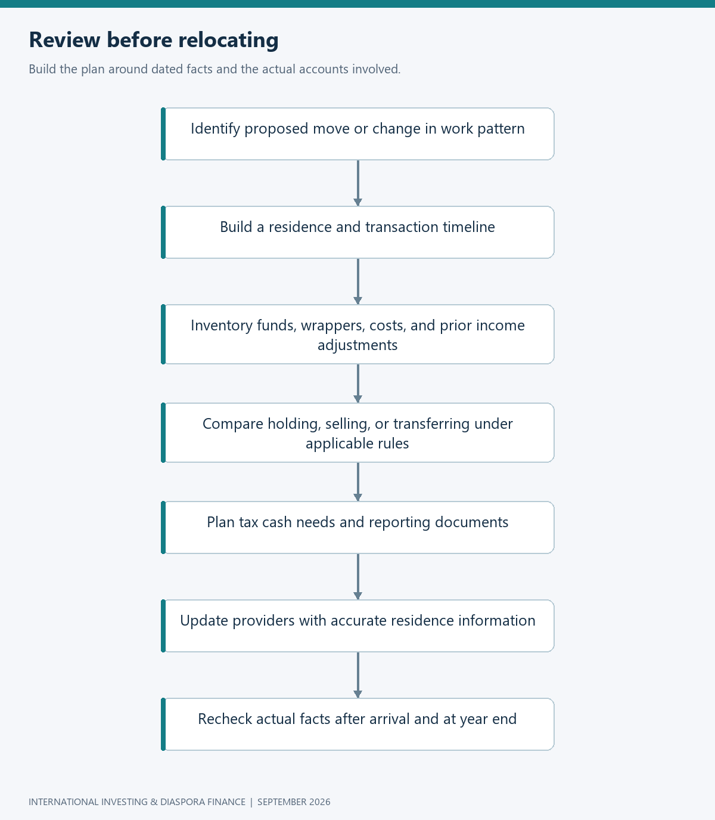
Flowchart: relocation review
The siblings now understand why copying one another’s portfolio is easier than copying one another’s tax outcome. Their investment decisions can remain straightforward, but each person needs a residence analysis, a record of relevant income events, and a way to fund obligations that may arise without distributions. The manual calculations have made those distinctions visible: days establish one residence branch, units create reportable income, an anniversary can trigger a deemed gain, and a statutory formula can recognise advance income. The remaining challenge is operational. How does income become investable cash, how does family support reach Kenya, and how can the household compare routes without confusing a low advertised fee with a low total cost? Part 3 follows that movement through bank accounts, IBKR, Wise, and Kenyan recipients, while keeping the investment plan and the family’s immediate needs connected.

References
[1] Kenya Revenue Authority, “Glossary: Resident individual,” n.d. [Online]. Available: KRA glossary. Accessed: Sep. 7, 2026.
[2] Kenya Revenue Authority, “Taxation of foreign income,” n.d. [Online]. Available: KRA guidance. Accessed: Sep. 7, 2026.
[3] Kenya Revenue Authority, “Capital gains tax,” n.d. [Online]. Available: KRA CGT guidance. Accessed: Sep. 7, 2026.
[4] HM Revenue & Customs, “1973 UK–Kenya Double Taxation Agreement as amended by the 1976 Protocol—in force,” arts. 4 and relevant income provisions. [Online]. Available: treaty text. Accessed: Sep. 7, 2026.
[5] HM Revenue & Customs, “RDR3 Statutory Residence Test,” updated Jun. 11, 2026. [Online]. Available: residence guidance. Accessed: Sep. 7, 2026.
[6] HM Revenue & Customs, “Tax on foreign income: Overview,” n.d. [Online]. Available: foreign-income guidance. Accessed: Sep. 7, 2026.
[7] HM Revenue & Customs, “Check if you can claim the 4-year foreign income and gains regime,” Apr. 6, 2025. [Online]. Available: FIG guidance. Accessed: Sep. 7, 2026.
[8] HM Revenue & Customs, “HS265 Offshore funds,” updated Apr. 6, 2026. [Online]. Available: offshore-fund helpsheet. Accessed: Sep. 7, 2026.
[9] HM Revenue & Customs, “Individual Savings Accounts: If you move abroad,” n.d. [Online]. Available: ISA guidance. Accessed: Sep. 7, 2026.
[10] Irish Revenue, “Investment Undertaking Tax Rate Change,” Revenue eBrief no. 016/26, Jan. 22, 2026. [Online]. Available: rate announcement. Accessed: Sep. 7, 2026.
[11] Irish Revenue, “Investment undertakings,” Tax and Duty Manual Part 27-01A-02, updated Jan. 2026, secs. 4.2–4.4. [Online]. Available: tax manual. Accessed: Sep. 7, 2026.
[12] Federal Ministry of Justice and Federal Office of Justice, “Investmentsteuergesetz,” secs. 18–20, current online text. [Online]. Available: German investment-tax statute. Accessed: Sep. 7, 2026.
[13] German Federal Ministry of Finance, “Basiszins zur Berechnung der Vorabpauschale … Basiszins zum 2. Januar 2026,” Jan. 13, 2026. [Online]. Available: official base-rate notice. Accessed: Sep. 7, 2026.
[14] A. Lusardi and O. S. Mitchell, “The economic importance of financial literacy: Theory and evidence,” Journal of Economic Literature, vol. 52, no. 1, pp. 5–44, 2014, doi: 10.1257/jel.52.1.5.

